

**FPT ACADEMY INTERNATIONAL FPT – APTECH COMPUTER EDUCATION**

**PROJECT: Coffee Shop**

**Semester: 04 Batch No: T1-1810E0**

# A.Hardware / Software Requirements

1. **Server Requirement**

* Hardware

|  |  |
| --- | --- |
| **Component** | **Requirement** |
| **CPU** | Processor type:  Pentium IV CPU 2.80 Ghz or higher. Processor speed:  Recommended: 2.0 GHz or faster |
| **OS** | Microsoft Windows Server 2012 with IIS |
| **Memory (RAM)** | RAM:  Minimum: 2 GB  Recommended: 3 GB or more |
| **Hard Drive** | Free space:  Minimum: 512 MB  Recommended: 50 GB or more  Maximum: Operating system maximum |

* Software

|  |  |
| --- | --- |
| **Component** | **Requirement** |
| **Eclipse** | 4.15.0 or higher |
| **RDBMS** | MySQL 8.0 or higher. |

1. **Client Requirement**

* Hardware

|  |  |
| --- | --- |
| **Component** | **Requirement** |
| **CPU** | Processor type:  Pentium III-compatible processor or faster  Processor speed:  Recommended: 1.0 GHz or faster |
| **OS** | All OS (Window, Linux, Android, Mac OS …) |
| **Memory (RAM)** | RAM:  Minimum: 1 GB  Recommended: 2 GB or more  Maximum: Operating system maximum |
| **Hard Drive** | Free space:  Minimum: 10 MB |

* Software

|  |  |
| --- | --- |
| **Component** | **Requirement** |
| **Web Browser** | Chrome (up to date). |

**B. Cài đặt chương trình**

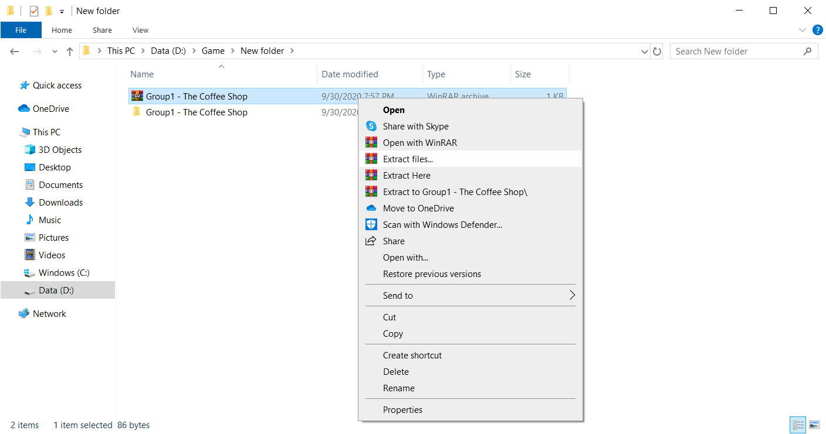 Step 1: Extract file

Step 2: Open Folder Group1-TheCoffeeShop.

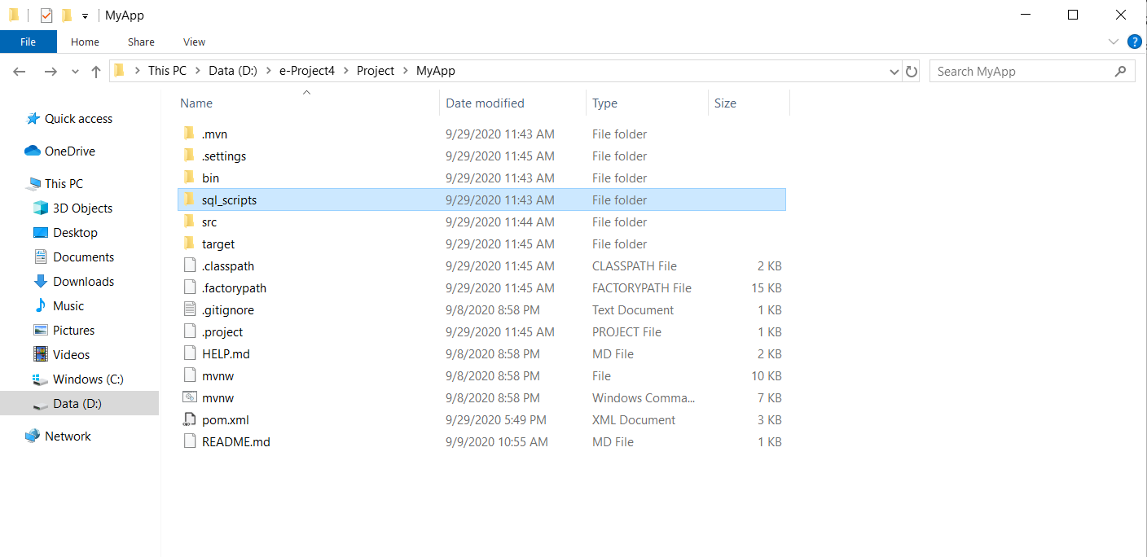

Step 3: Import File Maven The Coffee Shop

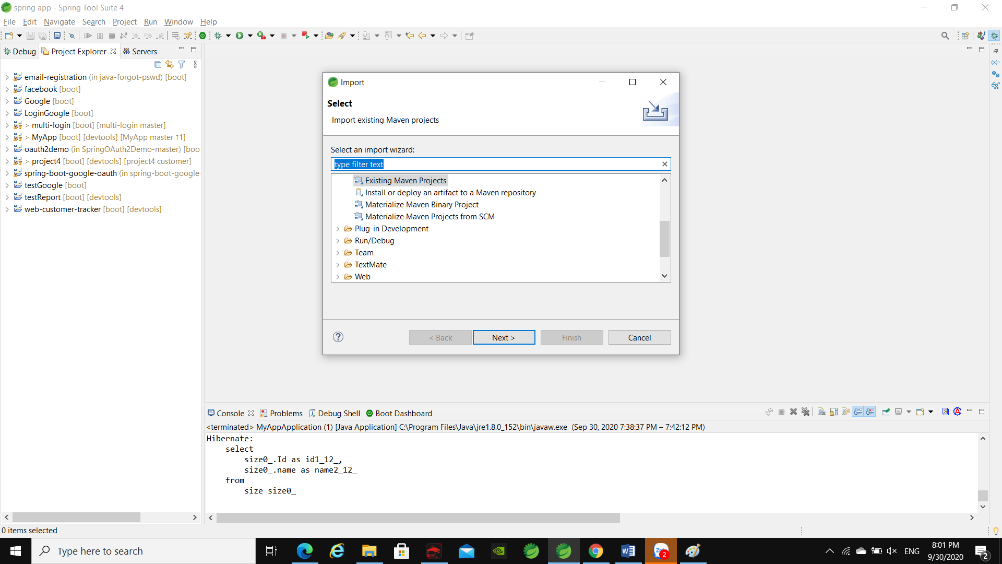

Step 7: Open MySQL Workbench

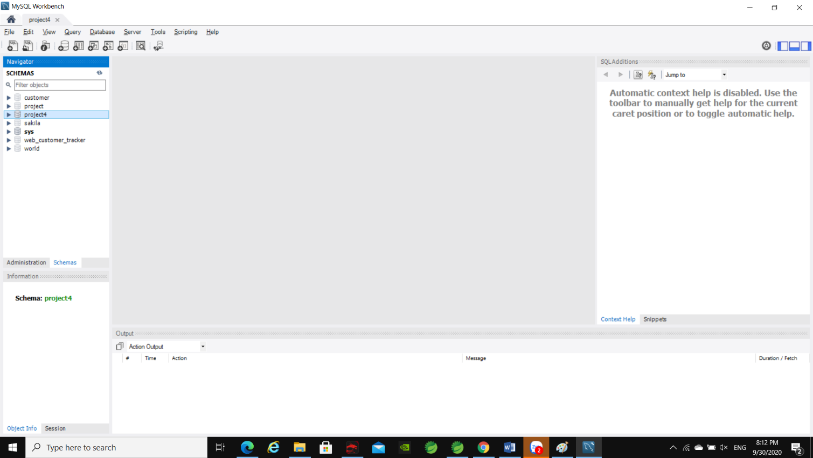

Step 8: Import file

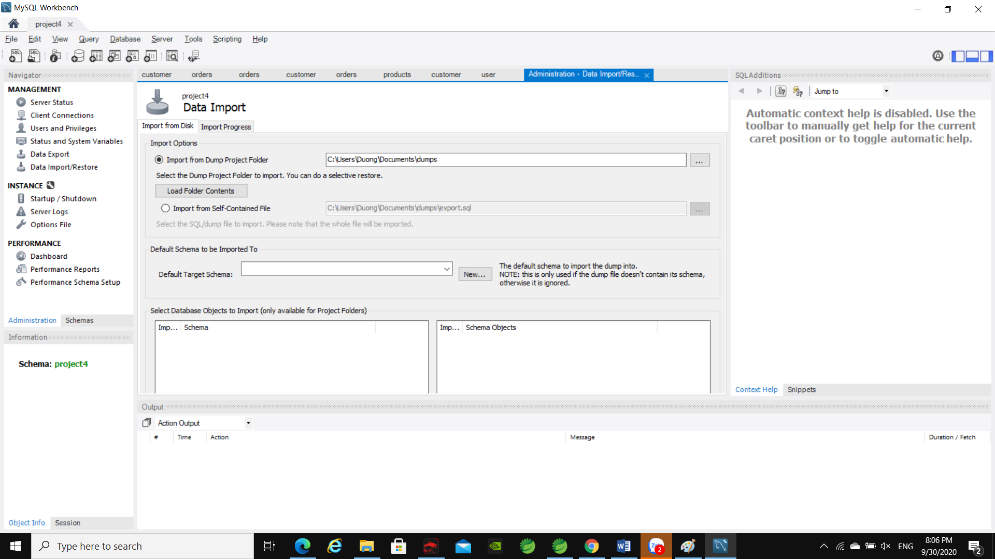

Step 9: Open Group1-TheCoffeeShop\db\Dump20200929

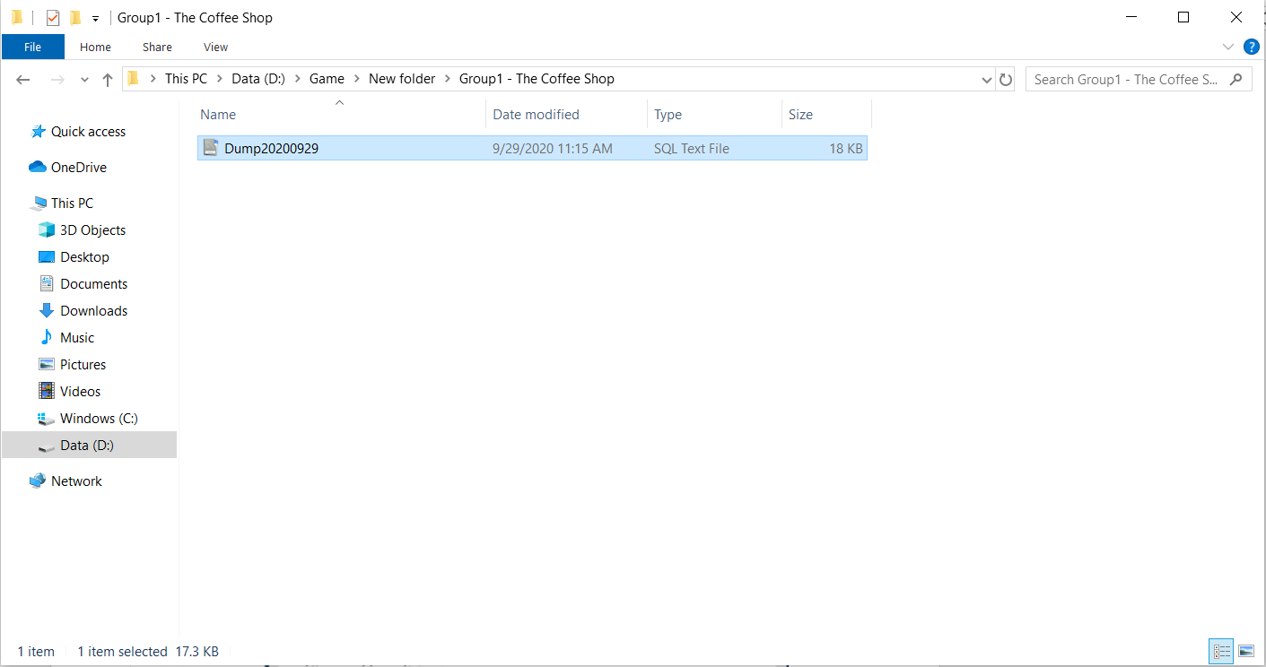

Step 11: Database name : eProject4

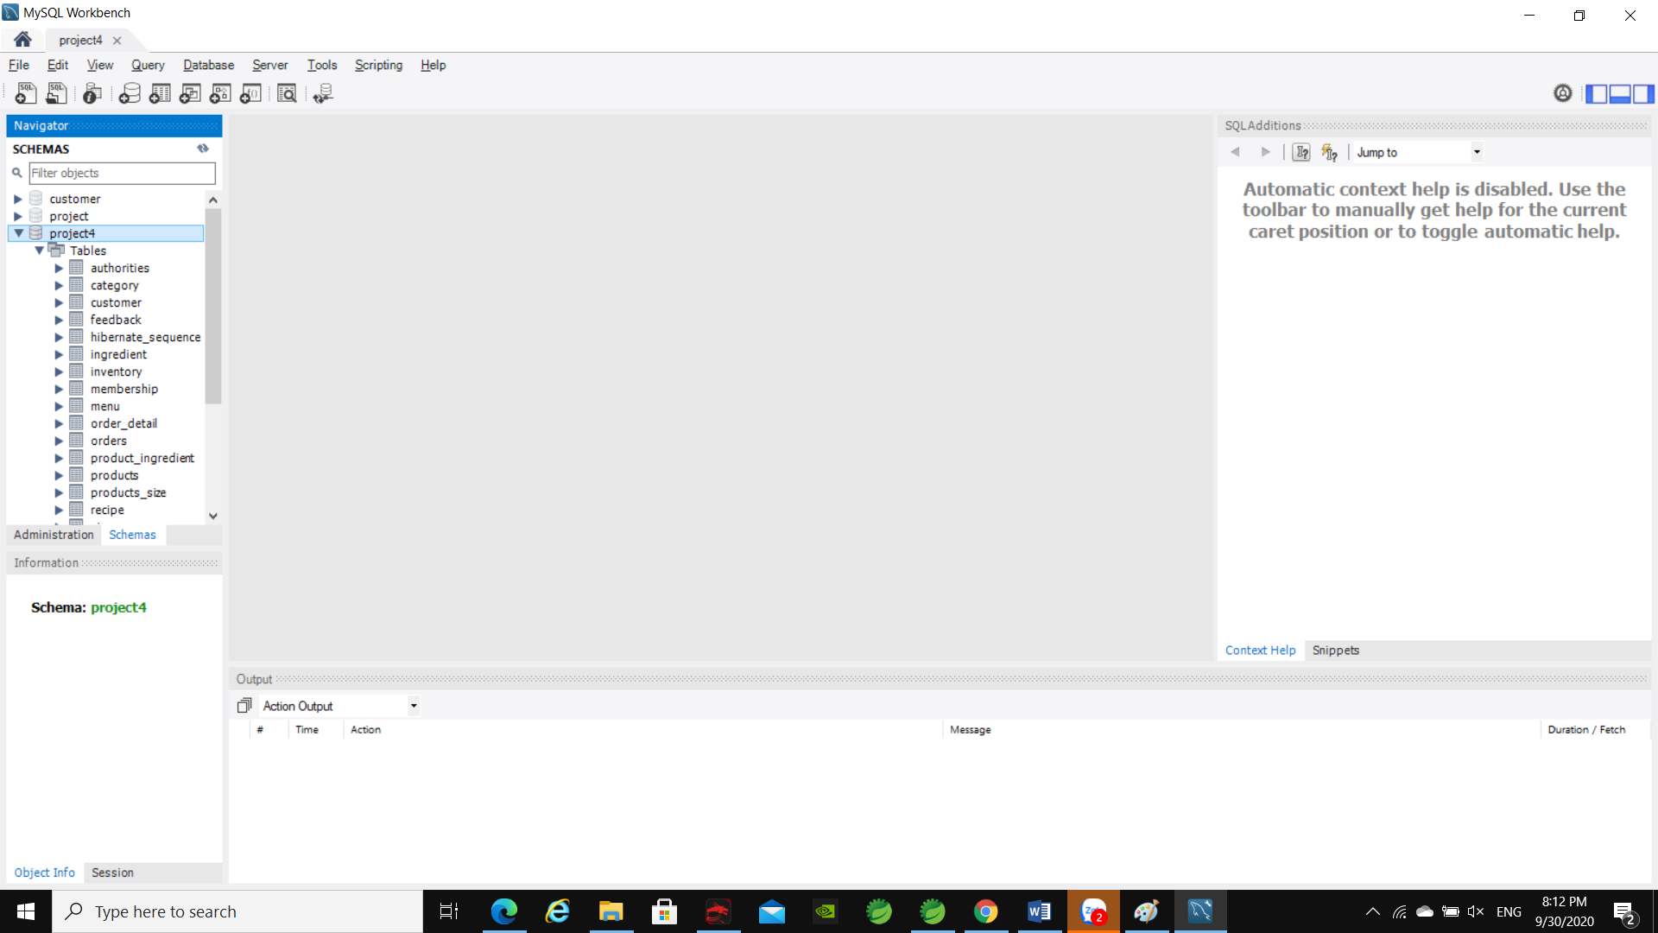

Complete

Step 13: Open Spring Boot. Click MyApp| Run As| Spring Boot App.

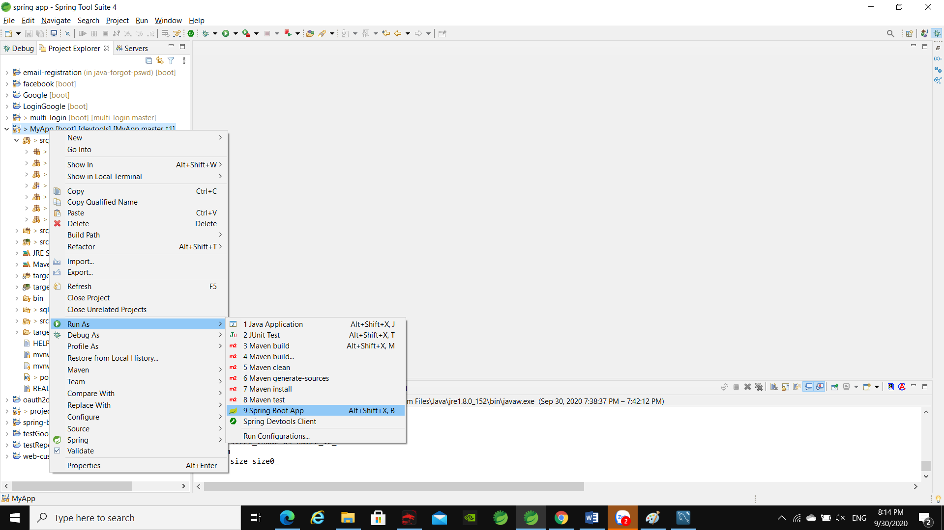

After Run

1. Web Client

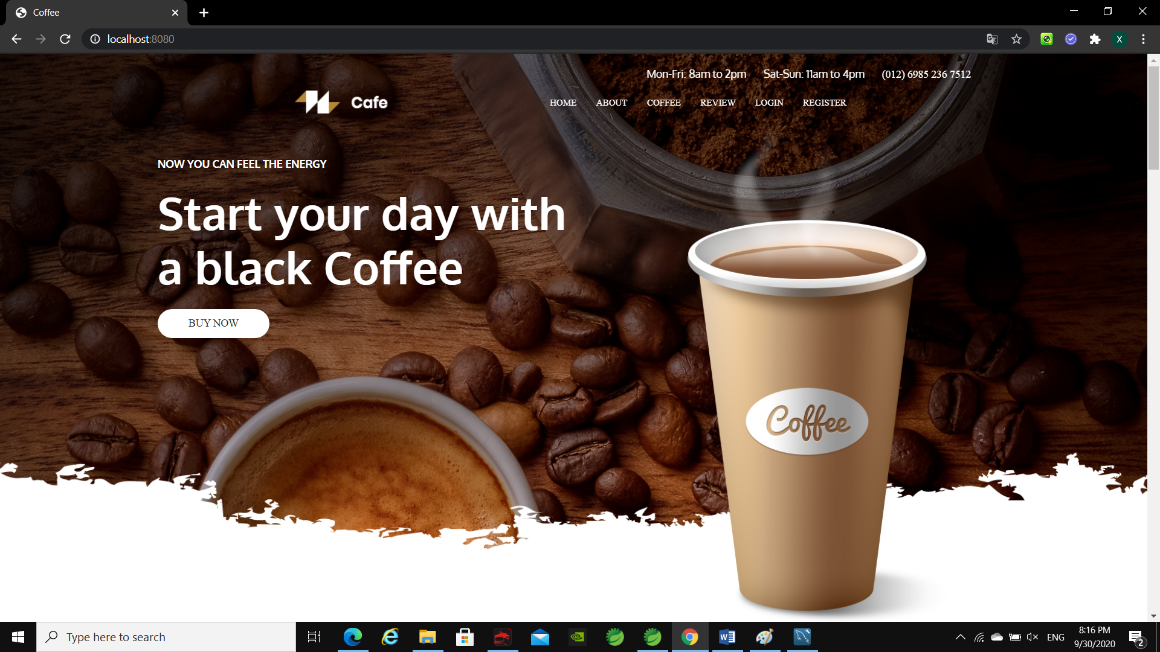

1. Web Admin

